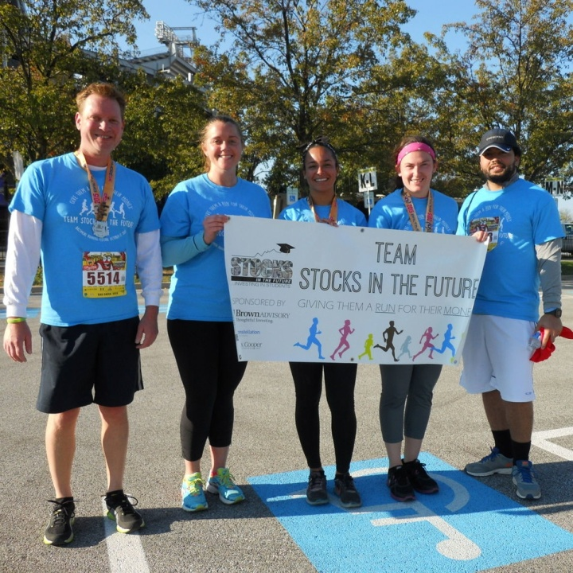
SIF is proud to be a Run for a Cause charity partner of the 2016 Baltimore Running Festival
16th Annual Baltimore Running Festival
Team SIF 2016
Baltimore Inner Harbor/Stadiums
Saturday, October 15, 2016

Let’s give them a run for their money.
Benefiting Stocks in the Future’s financial literacy program for
underserved middle school students in Baltimore City

2701 N. Charles St. | Suite 300 | Baltimore, MD 21218 | www.SIFonline.org
Table of Contents
About Stocks in the Future 3
SIF by the Numbers: 2015-16 Academic Year 3
About Team SIF 4
Team SIF Registration 4
Where to Register 4
Sponsorship Levels 5
Other Ways to Support Team SIF 6
Form a Corporate Team - Train and Fundraise Together 6
Donate 6
Volunteer 6
Raise Awareness 6
Sponsorship Levels Chart 7
Your Gift at Work at Stocks in the Future 8
Marketing Impressions 9
Sponsorship Agreement Form 10
For More Information 11
March Market Madness Event Committee 11

About Stocks in the Future
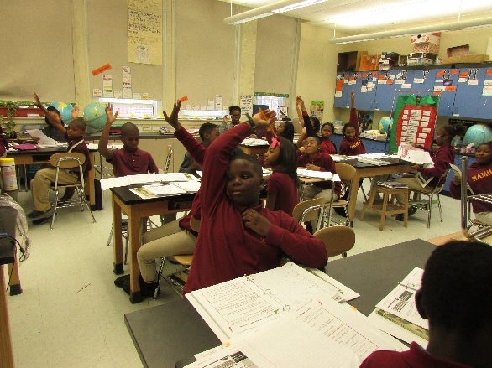
Stocks in the Future (SIF) works with underserved middle school student populations in Baltimore City. Through our specialized financial literacy curriculum and incentives, SIF gives middle schools a way to teach students financial life skills including personal finance, investing and business theory. Students participating in SIF’s program are given opportunity to earn “SIF Dollars” – an incentive to attend school regularly and earn better grades.
Our mission is to develop highly motivated middle school students who are eager to learn and dedicated to attending class through the use of incentives coupled with a financial literacy curriculum focused on investing that reinforces Math, Language Arts, and Social Studies.
Our vision is to see middle school students thrive in their classrooms, homes and neighborhoods by investing in their financial future and themselves.
Our core values are education, encouragement and empowerment.
Our rate of success:
- SIF reverses fifth graders’ poor attendance: By 6th grade absenteeism rates drop by four days during the year.
- 3-year SIF students (those who participated in the program in 6th, 7th and 8th grades) attend school two weeks more during that timeframe than their peers.
- Two SIF program pilots and evaluation results show SIF helps students master important new vocabulary, better comprehend non-fiction articles on investing/current events, and apply their mathematical knowledge.

SIF by the Numbers: 2015-16 Academic Year
- 18 schools
- 36 classrooms
- 900 middle school students
- 1,100+ program alumni (current high school students)

About Team SIF
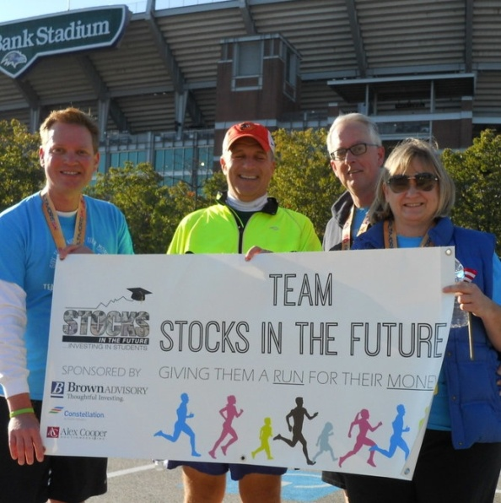
Team SIF is back at it again! On October 15, 2016 SIF volunteers, friends, staff, students and teachers will participate in the 16th Annual Baltimore Running Festival as Team Stocks in the Future (SIF). This year, Stocks in the Future is proud to be an official Run for a Cause partner of the Baltimore Running Festival: www.thebaltimoremarathon.com/run-for-a-cause/
In the name of team spirit and awareness-raising we’ll be outfitting Team SIF in new swag, and on the day of the Festival will host a post-race team celebration while catching glimpses of the Blue Angels demonstration, also scheduled for the same weekend.
In its debut year (2015) Team SIF raised more than $13,000 and had over 30 runners participating in the Running Festival. This year, we hope to double our performance to truly give the students we serve a "run for their money." Support our goals of raising $25,000+ and having over 50 Team SIF runners by getting involved today!
Proceeds will benefit Stocks in the Future's financial literacy program for middle school students. Learn more about our program at www.SIFonline.org

Team SIF Registration
Because SIF is an official charity partner of the Baltimore Running Festival, registration fees are locked in at the early bird rate through September 30, 2016:
Distance | Team SIF/Baltimore Running Festival Rate
Marathon | $100
Half Marathon | $90
Team Relay | $240
5K | $40
Kids (12 & under) Fun Run | $15

Where to Register
- Online by visiting www.crowdrise.com/TeamSIF
- If you prefer to register by phone, please contact the SIF office at 410-516-6883 and we will direct you to someone who can help.

Sponsorship Levels
For a full listing of sponsor benefits, please see the chart on page 8.
Presenting Sponsor - $2,500.00
1 sponsorship available
Make Team SIF possible! In addition to being named Presenting Sponsor of our team, your company will receive the highest visibility among Team SIF members, other race-goers, and Stocks in the Future’s supporters, constituents and networks. Your logo will be prominently featured on all promotional materials and publicity including: press releases, a pre- and post-race Facebook mentions, a hyperlink to your website from SIF’s site and the Team SIF homepage on Crowdrise, acknowledgement in SIF’s annual print newsletter and a special mid-summer edition of SIF’s e-newsletter, on the Team SIF banner, and on performance t-shirts which each Team SIF member will wear during the Baltimore Running Festival. Finally, your company will receive sole logo placement on the Team SIF 2016 water bottle and an ad insert in our Team SIF bags which will be distributed at the post-race team celebration.
Gold Level Sponsor - $1,000.00
5 sponsorships available
Gold Level sponsors will have a proportionate-sized logo on pre-race communications and promotional items: a pre-race Facebook mention, a hyperlink to your website from SIF’s site and the Team SIF homepage on Crowdrise, acknowledgement in SIF’s annual print newsletter and a special mid-summer edition of SIF’s e-newsletter, on the Team SIF banner, and on performance t-shirts which each Team SIF member will wear during the Baltimore Running Festival.
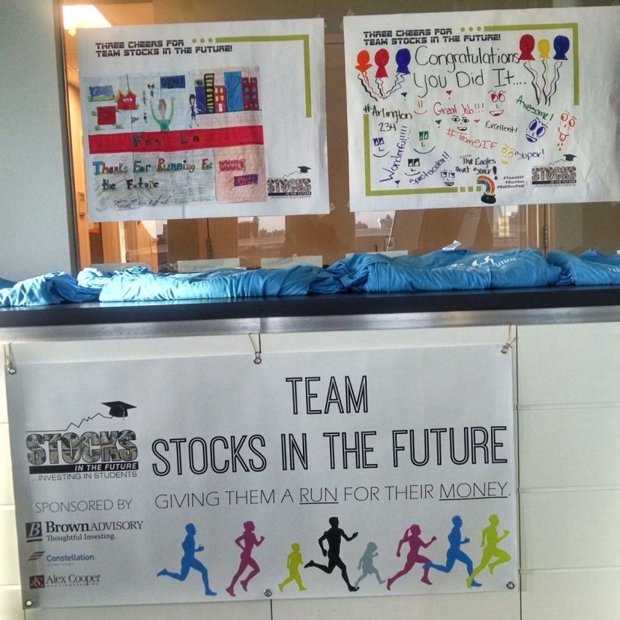
Bronze Level Sponsor - $500.00
5 sponsorships available
Support SIF’s middle school students while simultaneously getting your name out in the local community. Bronze Level sponsors will receive proportionate logo recognition on team T-shirts, a hyperlink to your website from SIF’s site and the Team SIF homepage on Crowdrise, and acknowledgement in SIF’s annual print newsletter and a special mid-summer edition of SIF’s e-newsletter.

Other Ways to Support Team SIF

Form a Corporate Team - Train and Fundraise Together
Grab two or more fellow runners from your place of business to run in support of SIF’s students. In addition to representing a company, teams can be a group of friends or neighbors. Teams can also represent a running club or civic organization, etc.
Groups should select a team captain. These leaders are responsible for:
- Being the liaison between team members and Stocks in the Future
- Ensuring their team members are registered as part of Team SIF before Oct. 1, 2016.
- Recruiting additional team members.
- Creating team fundraising goals and encouraging the team to meet them
To register your corporate team and begin fundraising, visit our Team SIF homepage (www.crowdrise.com/TeamSIF).

Donate
Consider making a gift in support of Team SIF. Visit www.crowdrise.com/TeamSIF and click “Donate.” You can designate your donation in honor of a specific corporate team or even an individual runner.
NEW! Join Team SIF as a virtual runner! Interested in showing your support for Team SIF but also really wanting to sleep in on October 15th? Well we’ve got the perfect race for you. Sign up as a virtual runner; to get all the perks of being a Team SIF member (who doesn’t want Team SIF swag?) while getting lounge around on Saturday! Visit www.crowdrise.com/TeamSIF and click “Register.”
Corporate Matching Gifts – Your Team SIF donation could easily double its impact if your employer participates in a matching gifts program. Talk to your HR representative for details on how to submit your gift for a corporate matching donation. For other general matching gift questions, contact Daniel Villalobos, SIF Development Assistant at dvillal1@jhu.edu or 410-516-6701. Last year, Team SIF raised nearly $2,000 from corporate matching gifts alone!

Volunteer
Team SIF is in need of volunteer photographers, greeters, well-wishers, and post-race celebration volunteers on Oct. 15. As an official Run for a Cause partner, SIF needs general volunteers for the Baltimore Running Festival (assignments will be provided by the Festival’s race coordinators). To volunteer with Team SIF, contact SIF at dvillal1@jhu.edu.

Raise Awareness
Visit Team SIF online at www.crowdrise.com/TeamSIF. This is your one-stop shop to support a Team SIF member and/or spread the word by inviting others to participate! You can also be a Team SIF social media ambassador and spread the word by sharing our Facebook updates and inviting friends to our Team SIF event on Facebook. Be sure to visit and like www.facebook.com/StocksintheFuture.

Sponsorship Levels Chart

Your Gift at Work at Stocks in the Future

Over the course of one academic year, your support helps accomplish the following:

Marketing Impressions
 | SIFonline.org | Facebook | SIF Update  (e-Newsletter) | SIF Exchange (annual print newsletter) | Team SIF homepage (on Crowdrise.com)
Followers | -- | 460 | -- | -- | --
Subscribers/  Circulation | 100+ site visits/month | -- | 1,175 | 500 | Anticipated 300+ site visits
Avg. Impressions per communication/peak impressions | -- | 75/350 | 250 | -- | --
Anticipated number of communications | Homepage event ad featuring sponsors runs June - October | 10+ | 1-2 | One | Sponsors listed on homepage June - October
Total impressions | 500+ | 750/3,500 | 250-500 | 500 | 300+
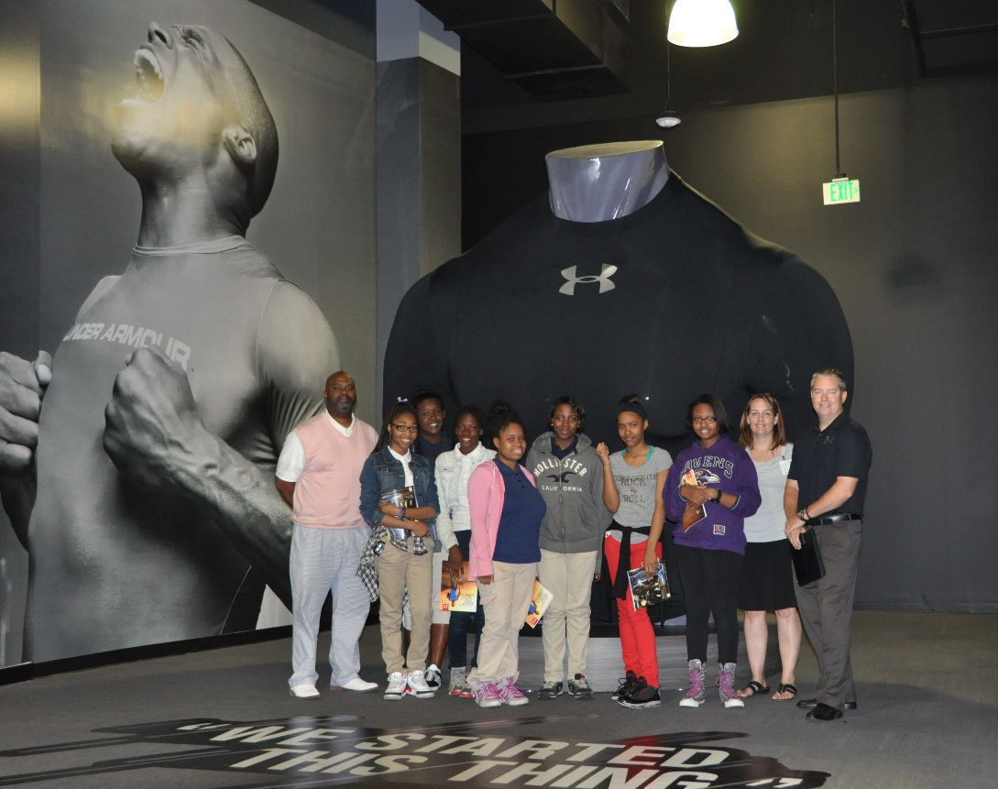

Sponsorship Agreement Form
Team SIF Sponsorship Agreement
Stocks in the Future, henceforth known as "Organization," and _______________ _{(business name)}, henceforth known as "Sponsor," enter into this agreement freely and willingly on the ________{(date)} day of ___________{(month)}, 2016.
The terms of this agreement are as follows:
The Event
Sponsor agrees to provide sponsorship (details below) for the 2016 Team SIF, henceforth known as "Fundraiser."
The Sponsorship
Sponsor agrees to provide Organization with a monetary sponsorship in the amount indicated below (please select a sponsorship level) for Fundraiser.
☐ Presenting Sponsor ($2,500.00)
☐ Bull Market Sponsor ($1,000.00)
☐ Financial Guru Sponsor ($500.00)
Credit
In exchange for this sponsorship, Organization agrees to sponsor recognition for the indicated sponsorship, as outlined in the Team SIF 2016 Sponsorship Opportunities Packet.
Delivery
Sponsor agrees that the item(s) listed above will be delivered to Organization no later than 30 days after the invoice date via check.
Relationship
This agreement represents the only relationship between Organization and Sponsor. No other relationship between the two entities exists, implied or otherwise.
____________________________ ____________________________
Sponsor Name Sponsor Signature
___________________________ ____________________________
Organization Representative Name Organization Representative Signature

For More Information

General Questions; Volunteers; Online Registration & Fundraising: Daniel Villalobos at dvillal1@jhu.edu or 410-516-6701.
Sponsorships: Rebecca Lange-Thernes at 410-516-6883 or rthernes@jhu.edu
Corporate Teams: JJ Baylin at 410-537-5499 or jbaylin@brownadvisory.com

March Market Madness Event Committee

JJ Baylin (Brown Advisory), Team SIF 2016 Chair
Sam Johnson (T. Rowe Price), Marketing Co-Coordinator
KC Cloyd (Constellation), Sponsorships Co-Coordinator
Andrew Struthers-Kennedy (Protiviti), Sponsorships Co-Coordinator
Rebecca Lange-Thernes, SIF Executive Director
Daniel Villalobos, SIF Development Assistant
Jessica McKearin, SIF Development Associate

