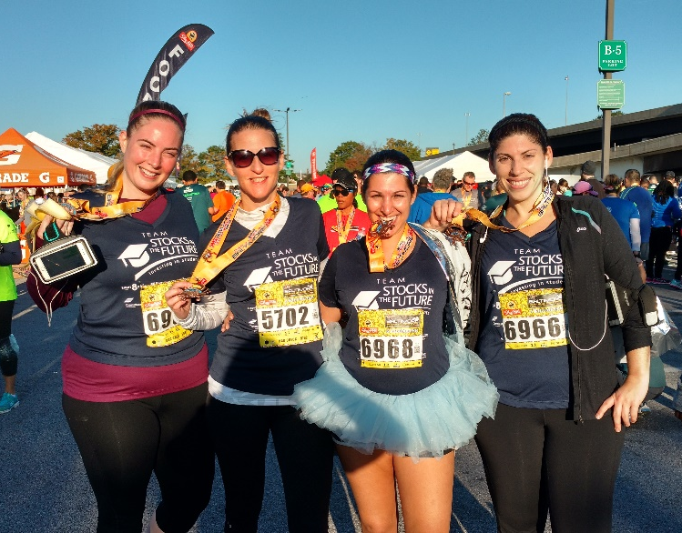
Let’s give them a run for their money.
Baltimore Inner Harbor/Stadiums
Saturday, October 21, 2017

17th Annual Baltimore Running Festival
Team SIF 2017
Benefiting Stocks in the Future’s financial literacy program for
underserved middle school students in Baltimore City

2701 N. Charles St. | Suite 300 | Baltimore, MD 21218 | www.SIFonline.org
Table of Contents
About Stocks in the Future 3
SIF stats: 2016-17 Academic Year 3
About Team SIF 4
Team SIF Registration 4
Where to Register for the Baltimore Running Festival 4
Where to Join Team SIF 4
Sponsorship Levels 5
Other Ways to Support Team SIF 6
Form a Corporate Team - Train and Fundraise Together 6
Donate 6
Volunteer 6
Raise Awareness 6
Sponsorship Levels Chart 8
Your Gift at Work at Stocks in the Future 9
Marketing Impressions 10
Sponsorship Agreement Form 11
For More Information 12

About Stocks in the Future
Stocks in the Future (SIF) works with underserved middle school student populations in Baltimore City. Through our specialized financial literacy curriculum and incentives, SIF gives middle schools a way to teach students financial life skills including personal finance, investing and business theory. Students participating in SIF’s program are given opportunity to earn “SIF Dollars” – an incentive to attend school regularly and earn better grades.
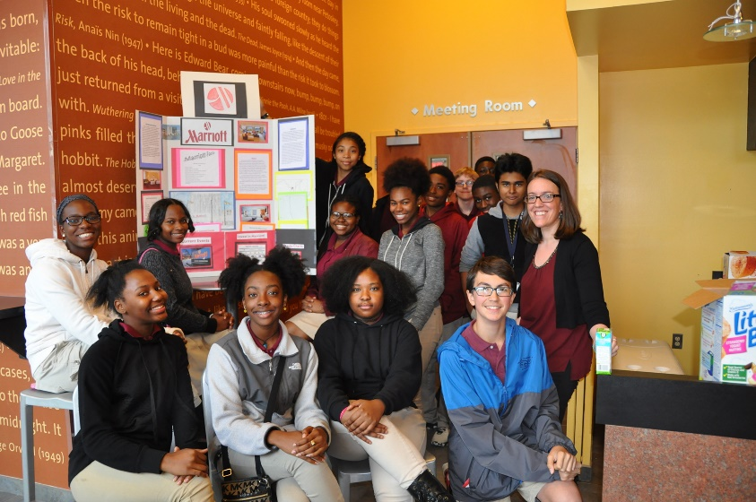
Our mission is to develop highly motivated middle school students who are eager to learn and dedicated to attending class through the use of incentives coupled with a financial literacy curriculum focused on investing that reinforces Math, Language Arts, and Social Studies.
Our vision is to see middle school students thrive in their classrooms, homes and neighborhoods by investing in their financial future and themselves.
Our core values are education, encouragement and empowerment.
Our outcomes (as reported by SIF’s independent program evaluation study, published in Oct. 2016):
SIF students were significantly more likely TO GAIN in these areas…
- Reading Comprehension; 8th graders scores grew 10%
- Financial Vocabulary; 7th grade scores grew by 15%
- Math Concepts and Calculations; 7th grade scores grew by 7% and 8th by 15%
Data used in this study was drawn from the HSAT (Hopkins Short Achievement Test,) a direct assessment used to evaluate financial literacy. The HSAT also gave evidence that 6th graders form a solid base of knowledge in financial literacy, giving them opportunity to achieve during subsequent years in the program.

SIF stats: 2016-17 Academic Year
- List of school partners: http://www.sifonline.org/current-schools/
- 850 middle school students
- 1,100+ program alumni (current high school students)

About Team SIF
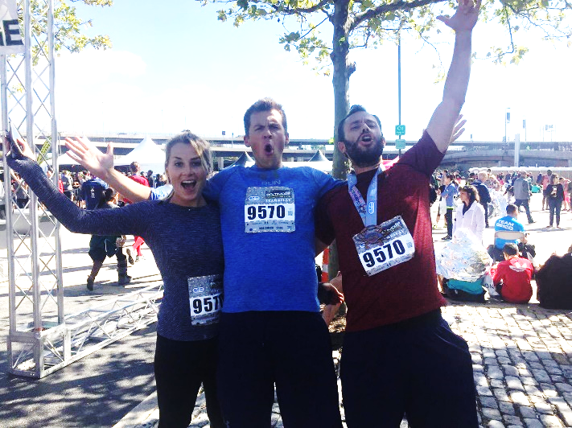
Team SIF is back at it again! On October 21, 2017 SIF volunteers, friends, staff, students and teachers will participate in the 17th Annual Baltimore Running Festival as Team Stocks in the Future (SIF).
In the name of team spirit and awareness-raising we’ll be outfitting Team SIF in new swag, and the week leading up to the Festival will host a pre-race team celebration and happy hour.
Since 2015, Team SIF has raised approximately $30,000 to support youth financial literacy and has had more than 80 runners participating in the Running Festival. This year, we will give the students we serve the best "run for their money," yet! Support our goals of raising $25,000+ and having over 50 Team SIF runners by getting involved today!
Proceeds will benefit Stocks in the Future's financial literacy program for middle school students. Learn more about our program at www.SIFonline.org

Team SIF Registration

Where to Register for the Baltimore Running Festival
- Online by visiting http://www.thebaltimoremarathon.com/
- Distances include 5K, Half & Full Marathons, Marathon Relay and Kids Fun Run

Are you registered? Great! Now it’s time to join Team SIF…

Where to Join Team SIF
- Online by visiting https://www.crowdrise.com/TeamSIF17
- If you are fundraising on behalf of an existing team, scroll down the landing page and click on the team of your choice from the “team leaderboard.” Follow the prompts to donate, or copy and share the team page link to your family, friends, colleagues.
- To create your own fundraising page (i.e., you are not affiliated with a corporate team), visit https://www.crowdrise.com/TeamSIF17 and click the grey “Set Up Your Fundraiser” button.
- If you would like to create a team, please contact Stocks in the Future at sifadmin@jhu.edu or 410-516-6883.

Sponsorship Levels
For a full listing of sponsor benefits, please see the chart on page 8.
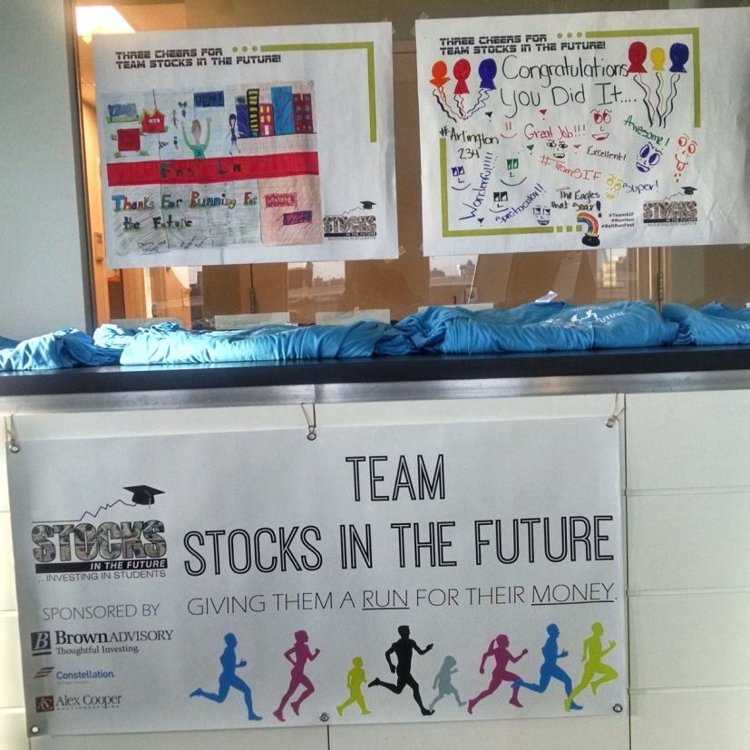
Presenting Sponsor - $2,500.00
1 sponsorship available
Make Team SIF possible! In addition to being named Presenting Sponsor of our team, your company will receive the highest visibility among Team SIF members, other race-goers, and Stocks in the Future’s supporters, constituents and networks. Your logo will be prominently featured on all promotional materials and publicity including: press releases, a pre- and post-race Facebook mentions, a hyperlink to your website from SIF’s site and the Team SIF homepage on Crowdrise, acknowledgement in SIF’s annual print newsletter, on the Team SIF banner, and on performance t-shirts which each Team SIF member will wear during the Baltimore Running Festival.
Gold Level Sponsor - $1,000.00
5 sponsorships available
Gold Level sponsors will have a proportionate-sized logo on pre-race communications and promotional items: a pre-race Facebook mention, a hyperlink to your website from SIF’s site and the Team SIF homepage on Crowdrise, acknowledgement in SIF’s annual print newsletter, on the Team SIF banner, and on performance t-shirts which each Team SIF member will wear during the Baltimore Running Festival.
Bronze Level Sponsor - $500.00
5 sponsorships available
Support SIF’s middle school students while simultaneously getting your name out in the local community. Bronze Level sponsors will receive proportionate logo recognition on team T-shirts, a hyperlink to your website from SIF’s site and the Team SIF homepage on Crowdrise, and acknowledgement in SIF’s annual print newsletter.

Other Ways to Support Team SIF:

Form a Corporate Team - Train and Fundraise Together
Grab two or more fellow runners from your place of business to run in support of SIF’s students. In addition to representing a company, teams can be a group of friends or neighbors. Teams can also represent a running club or civic organization, etc.
Groups should select a team captain. These leaders are responsible for:
- Being the liaison between team members and Stocks in the Future
- Recruiting additional team members
- Creating team fundraising goals and encouraging the team to meet them
To register your corporate team and begin fundraising, please contact Stocks in the Future at sifadmin@jhu.edu or call 410-516-6883.

Donate
Consider making a gift in support of Team SIF. Visit http://www.crowdrise.com/TeamSIF17 and click “Donate.” You can designate your donation in honor of a specific corporate team or as applicable, individual runner.
NEW! Join Team SIF as a virtual runner! Interested in showing your support for Team SIF but also really wanting to sleep in on October 21st? Well we’ve got the perfect race for you. Sign up as a virtual runner; to get all the perks of being a Team SIF member (who doesn’t want Team SIF swag?) while getting lounge around on Saturday! Visit www.crowdrise.com/teamvirtual-sif and follow the prompts to make a donation. Be sure to include your name on the donation form so we can include you in the t-shirt order. Thanks for your minimum $30 donation in order to receive a team shirt.
Corporate Matching Gifts – Your Team SIF donation could easily double its impact if your employer participates in a matching gifts program. Talk to your HR representative for details on how to submit your gift for a corporate matching donation. For other general matching gift questions, contact Stocks in the Future at sifadmin@jhu.edu or 410-516-6883. Last year, Team SIF raised thousands of dollars from corporate matching gifts alone!

Volunteer
Team SIF is in need of volunteer photographers and pre-race celebration volunteers on Oct. 21. To volunteer with Team SIF, contact SIF at sifadmin@jhu.edu or 410-516-6883.

Raise Awareness
Visit Team SIF online at www.crowdrise.com/TeamSIF17. This is your one-stop shop to support a Team SIF member and/or spread the word by inviting others to participate! You can also be a Team SIF social media ambassador and spread the word by sharing our Facebook updates and inviting friends to our Team SIF event on Facebook. Be sure to visit and like www.facebook.com/StocksintheFuture.

Sponsorship Levels Chart

Your Gift at Work at Stocks in the Future

Over the course of one academic year, your support helps accomplish the following:

Marketing Impressions
 | SIFonline.org | Facebook | SIF Update  (e-Newsletter) | SIF Exchange (annual print newsletter) | Team SIF homepage (on Crowdrise.com)
Followers | -- | 535 | -- | -- | --
Subscribers/  Circulation | 100+ site visits/month | -- | 1,190 | 500 | Anticipated 300+ site visits
Avg. Impressions per communication/peak impressions | -- | 75/350 | 250 | -- | --
Anticipated number of communications | Homepage event ad featuring sponsors runs June - October | 10+ | 1-2 | One | Sponsors listed on homepage June - October
Total impressions | 500+ | 750/3,500 | 250-500 | 500 | 300+
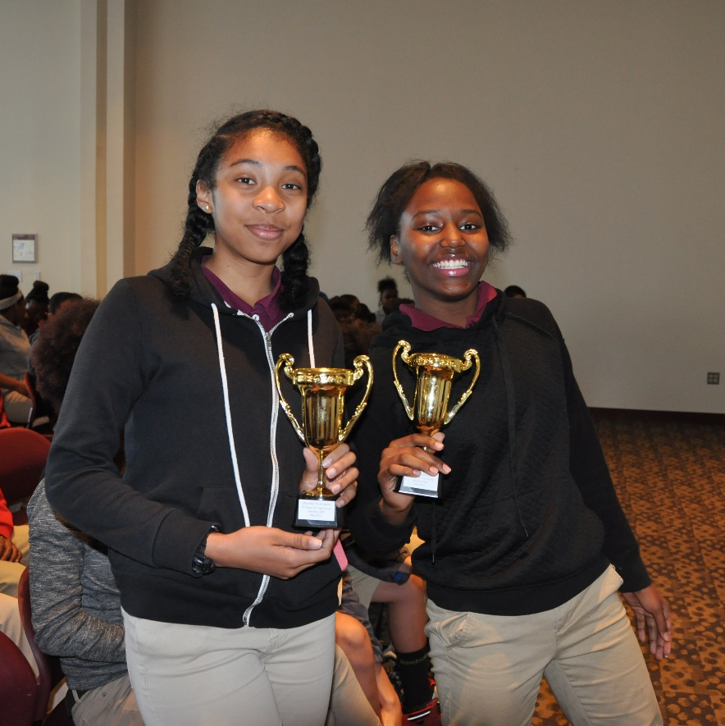

Sponsorship Agreement Form
Team SIF Sponsorship Agreement
Stocks in the Future, henceforth known as "Organization," and _______________ _{(business name)}, henceforth known as "Sponsor," enter into this agreement freely and willingly on the ________{(date)} day of ___________{(month)}, 2017.
The terms of this agreement are as follows:
The Event
Sponsor agrees to provide sponsorship (details below) for the 2017 Team SIF, henceforth known as "Fundraiser."
The Sponsorship
Sponsor agrees to provide Organization with a monetary sponsorship in the amount indicated below (please select a sponsorship level) for Fundraiser.
☐ Presenting Sponsor ($2,500.00)
☐ Bull Market Sponsor ($1,000.00)
☐ Financial Guru Sponsor ($500.00)
Credit
In exchange for this sponsorship, Organization agrees to sponsor recognition for the indicated sponsorship, as outlined in the Team SIF 2017 Sponsorship Opportunities Packet.
Delivery
Sponsor agrees that the item(s) listed above will be delivered to Organization no later than 30 days after the invoice date via check.
Relationship
This agreement represents the only relationship between Organization and Sponsor. No other relationship between the two entities exists, implied or otherwise.
____________________________ ____________________________
Sponsor Name Sponsor Signature
___________________________ ____________________________
Organization Representative Name Organization Representative Signature

For More Information

General Questions; Volunteers; Online Registration & Fundraising: sifadmin@jhu.edu
Sponsorships: Rebecca Lange-Thernes at 410-516-6883 or rthernes@jhu.edu
Corporate Teams: KC Cloyd (SIF Board of Directors) at 410-470-3334 or kathryncloyd@gmail.com

